Authority（权威） Social Proof（从众） Scarcity（稀缺） Emotional Appeal（情绪唤起） Personal Identity（身份映射） Humor（幽默） Trustworthiness（可信度） Familiarity（熟悉感） Novelty（新奇性）

Pair 1：Authority（权威） vs Non-Authority

A（Authority）：

A doctor in a white coat and stethoscope stands confidently against a bright hospital background, holding up a beverage, with professional medical charts beside him.



B（Non-Authority）：

A regular young man was standing in the park casually drinking a beverage, without any professional background.



Pair 2：Social Proof（从众） vs Non-Social Proof

A（Social Proof）：

A group of people of different ages and ethnicities were lining up to buy the same drink, all with expectant expressions on their faces.

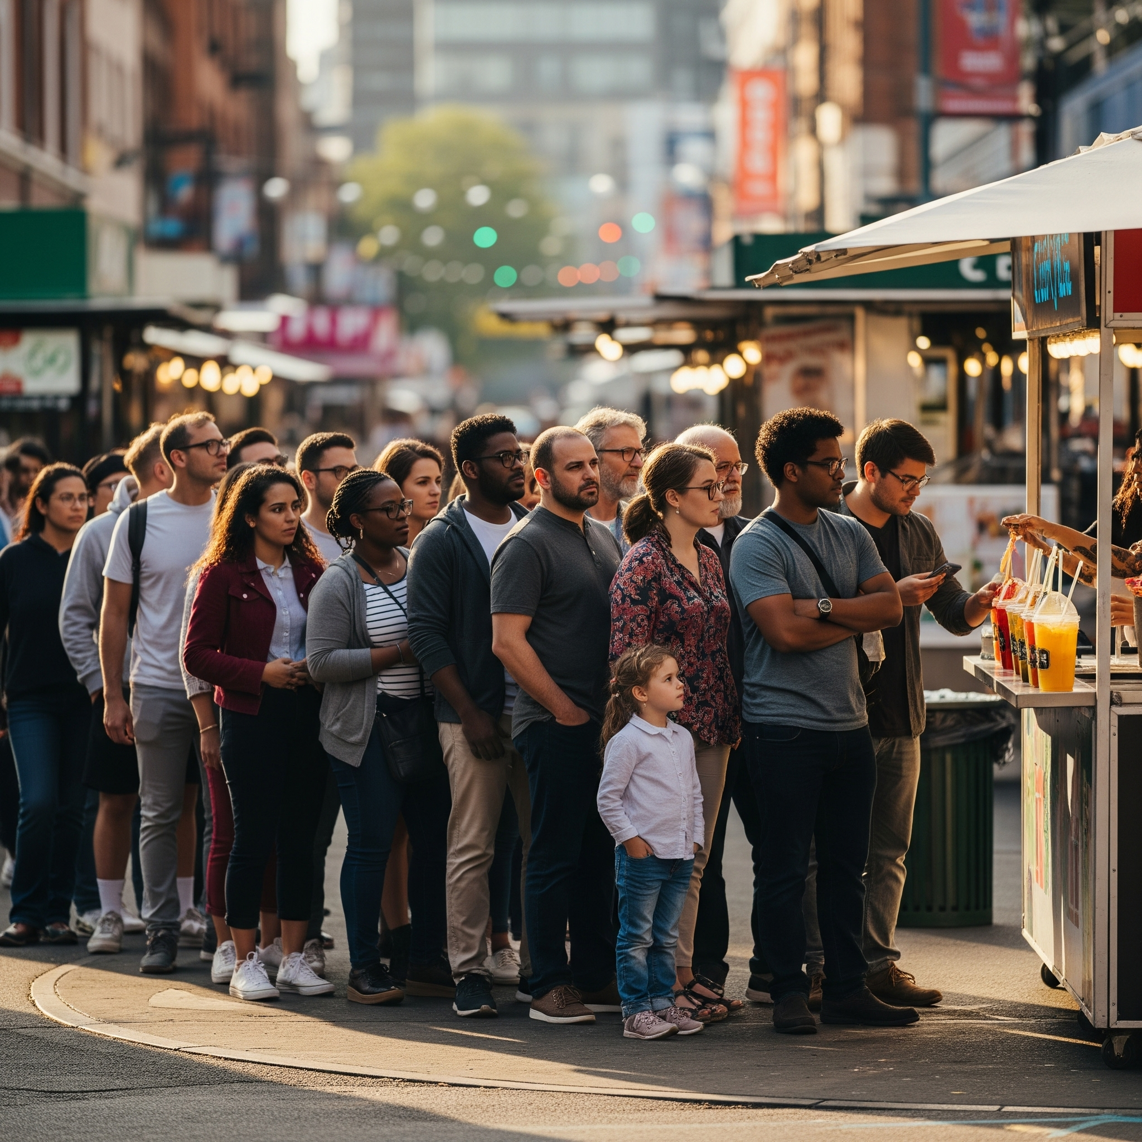

B（Non-Social Proof）：

There was only one person in front of the shelves, casually looking at the drinks, showing no signs of being affected.

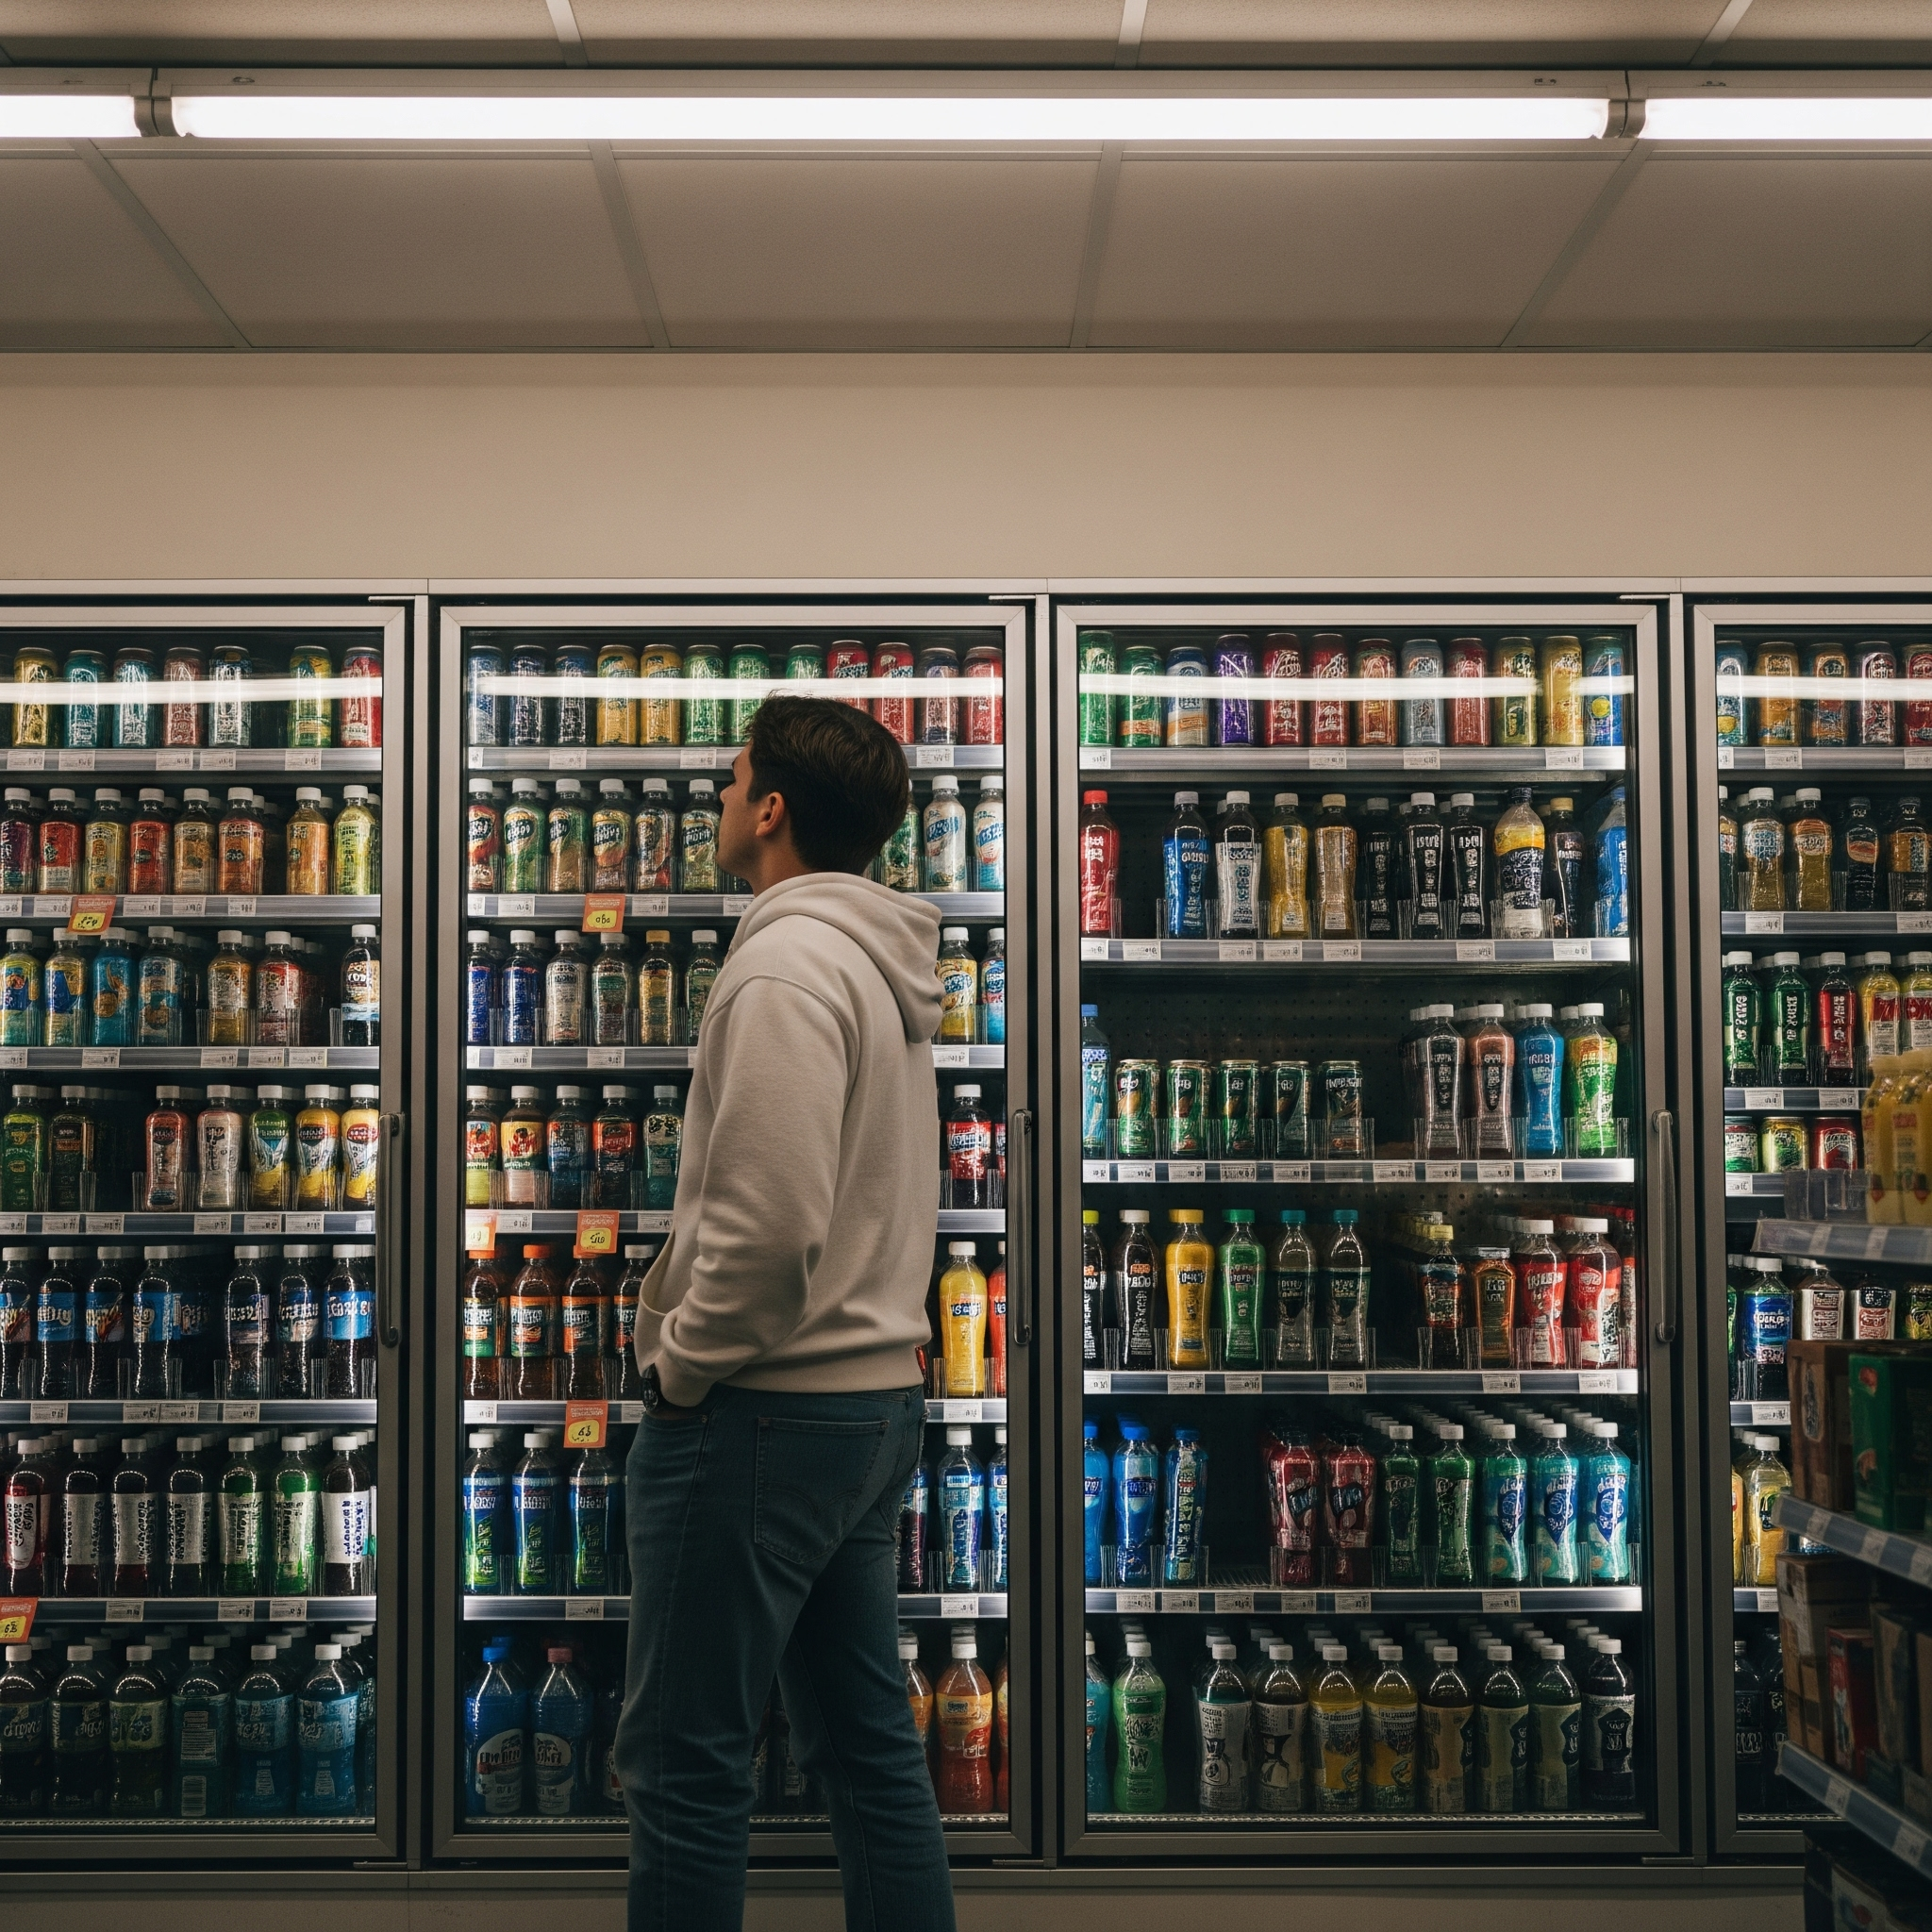

Pair 3: Scarcity vs Non-Scarcity

A — Scarcity

A supermarket shelf with only one bottle of the beverage left, with a visible “LIMITED” or “ONLY ONE LEFT” label. Creates urgency and scarcity. Dramatic lighting optional.

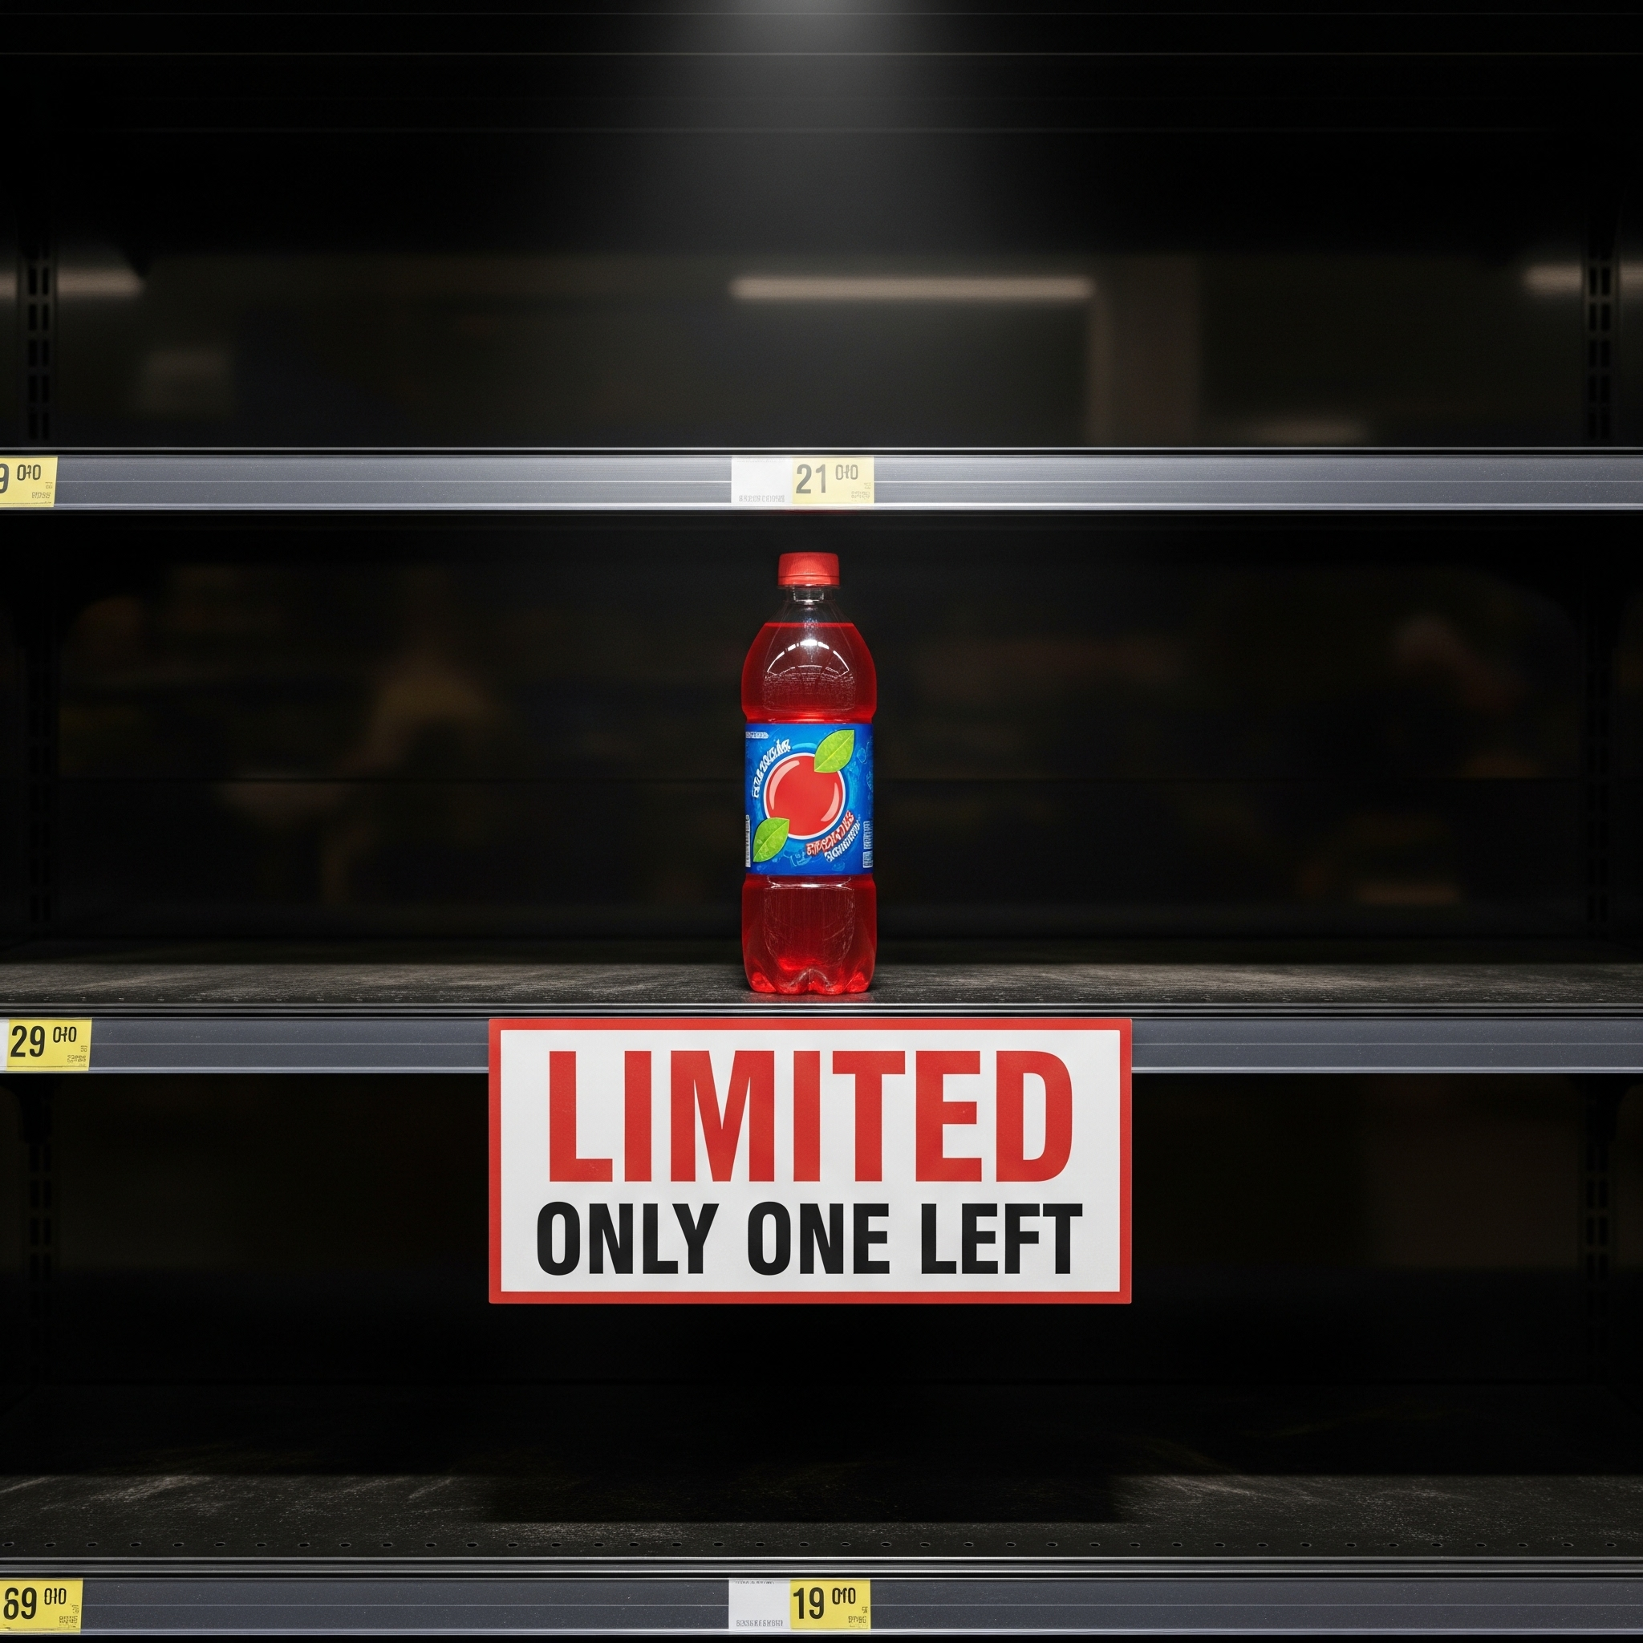

B Non-Scarcity

The same supermarket shelf fully stocked with many bottles of the beverage. No urgency, ordinary display, calm scene.

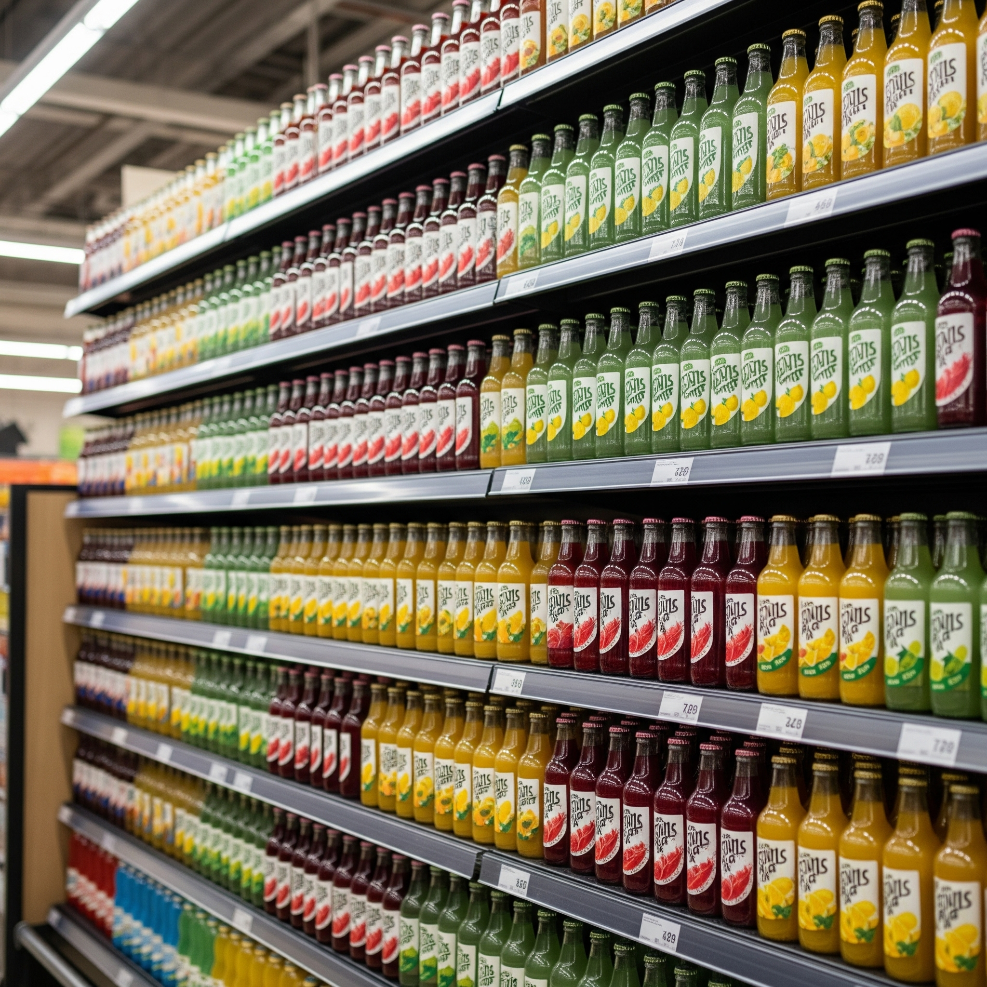

Pair 4: Emotional Appeal vs Neutral

A — Emotional Appeal

Prompt:

A father playing with his young daughter at sunset, warm golden light illuminating the moment. The girl is holding a beverage bottle. Strong emotional warmth, touching family atmosphere.

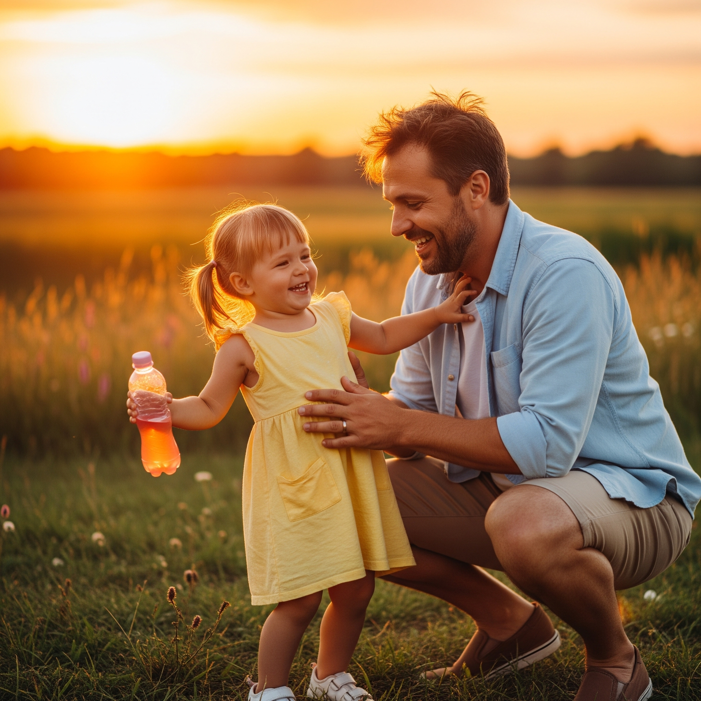

B — Neutral

Prompt:

A bottle of the beverage placed on a plain table with a simple, neutral background. No people, no emotional elements, minimalistic.

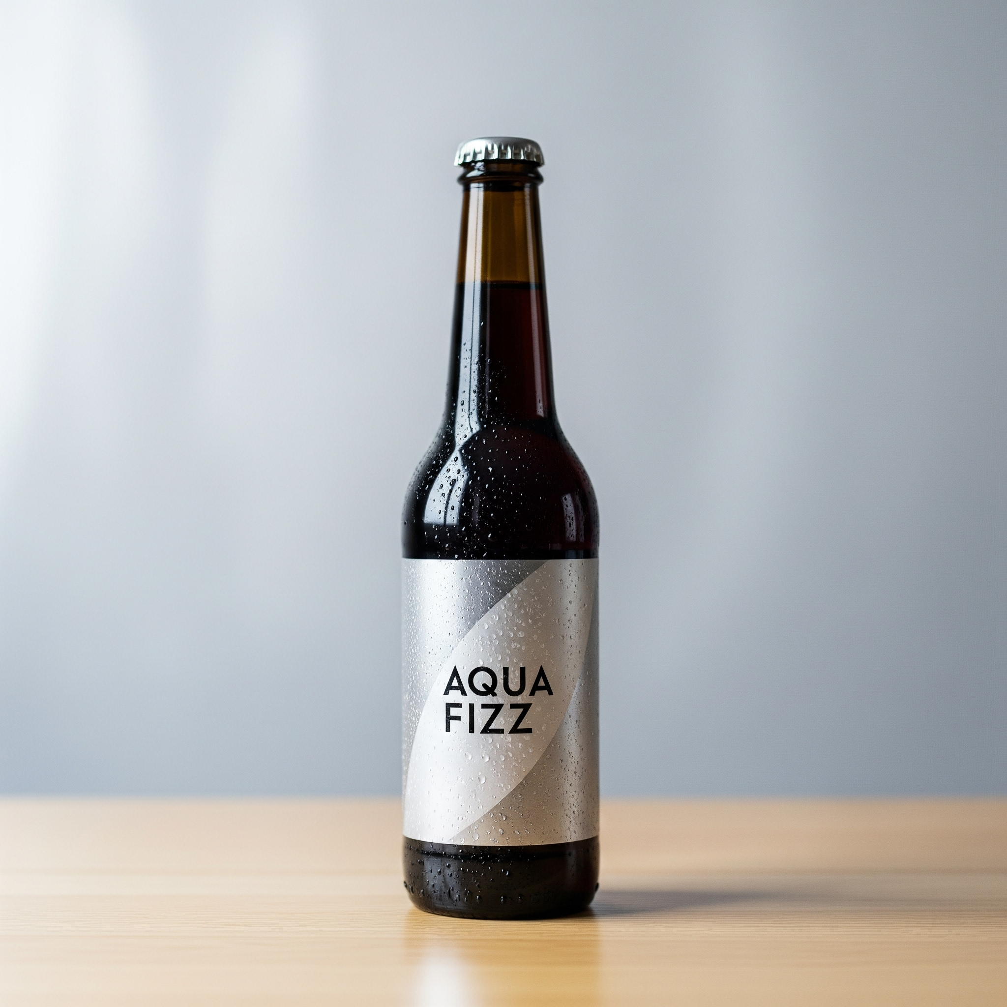

Pair 5: Personal Identity vs Non-Identity

A — Personal Identity

Prompt:

A young woman drinking a beverage in a gym, with text “Stronger Me” subtly visible in the scene. Messaging conveys self-improvement and identity empowerment. Energetic lighting.

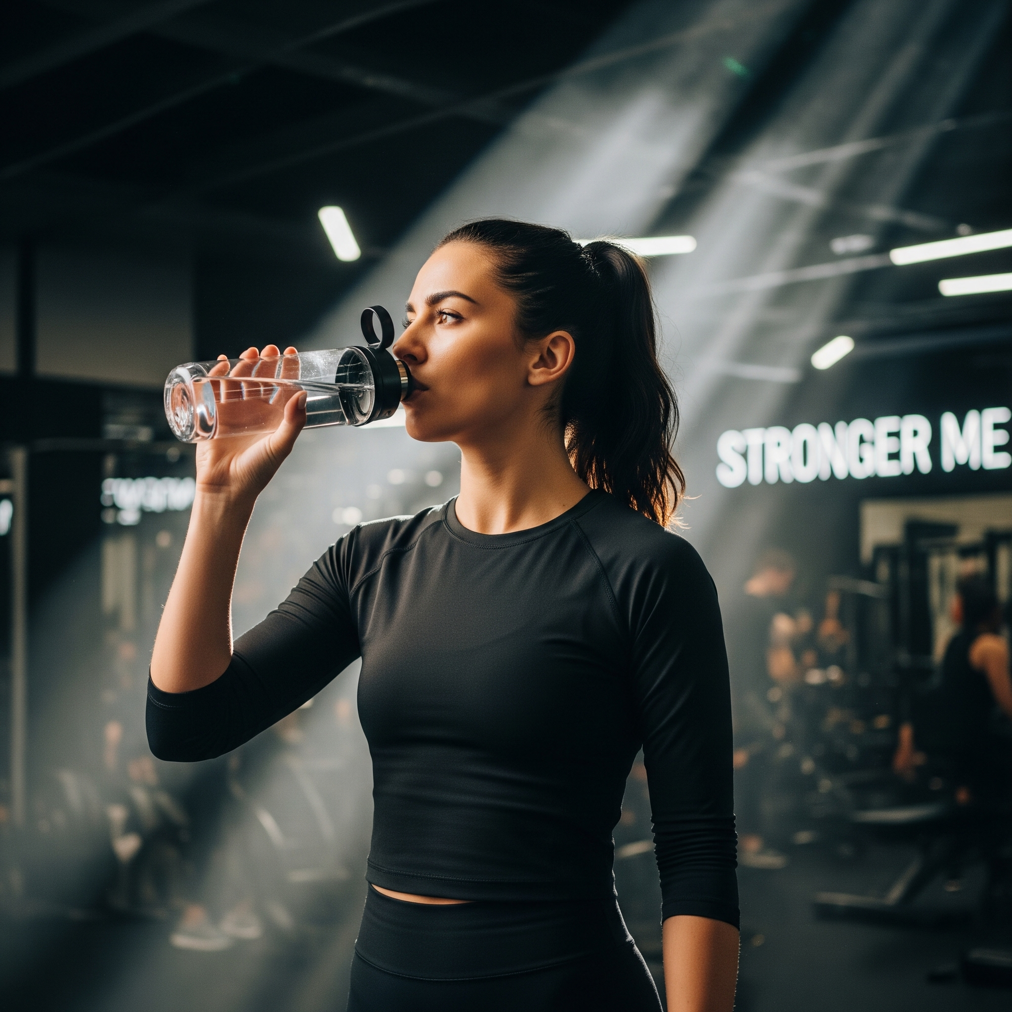

B — Non-Identity

Prompt:

The same young woman drinking the beverage casually on a city street. No identity messaging, no motivational elements.

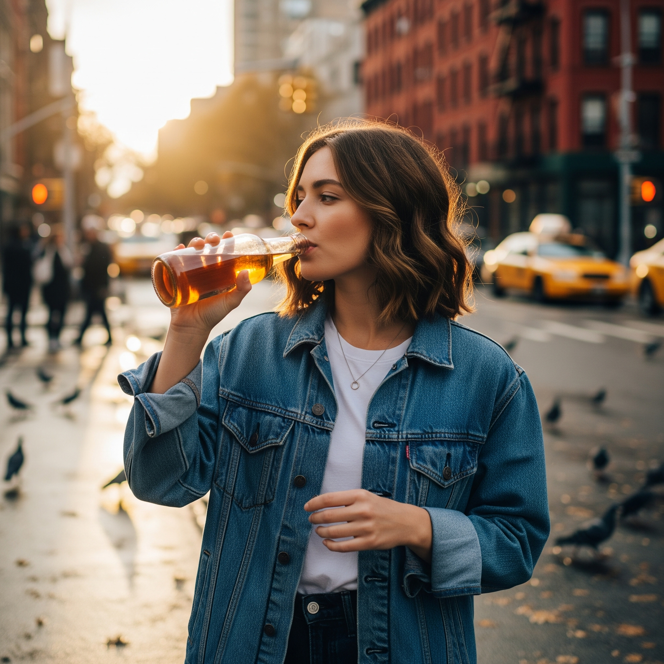

Pair 6: Humor vs Non-Humor

A — Humor

Prompt:

A beverage bottle with cartoon-style legs running in a race, with exaggerated facial expression. Other beverage bottles on the sidelines cheering. Playful, humorous, high-energy style.

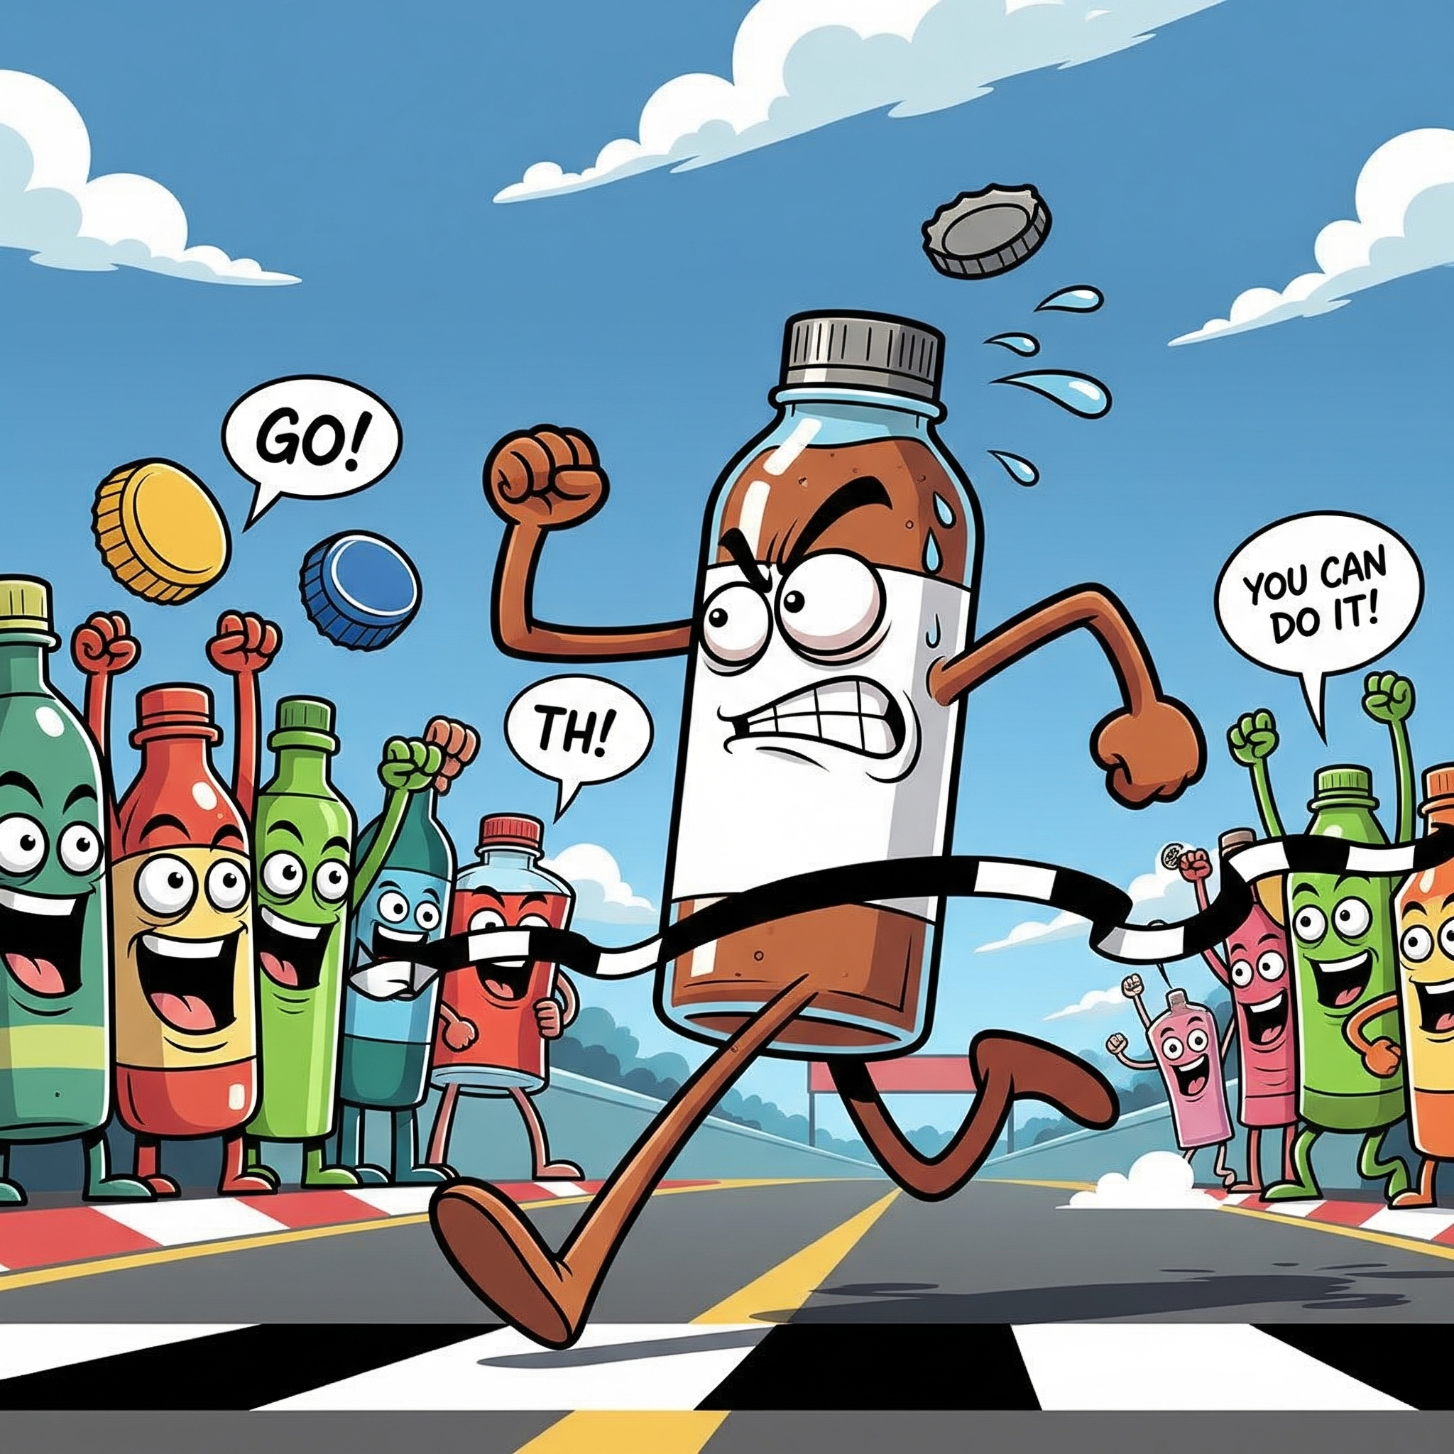

B — Non-Humor

Prompt:

A standard product photo of the beverage bottle on a clean surface, no humor, no characters, simple studio lighting.

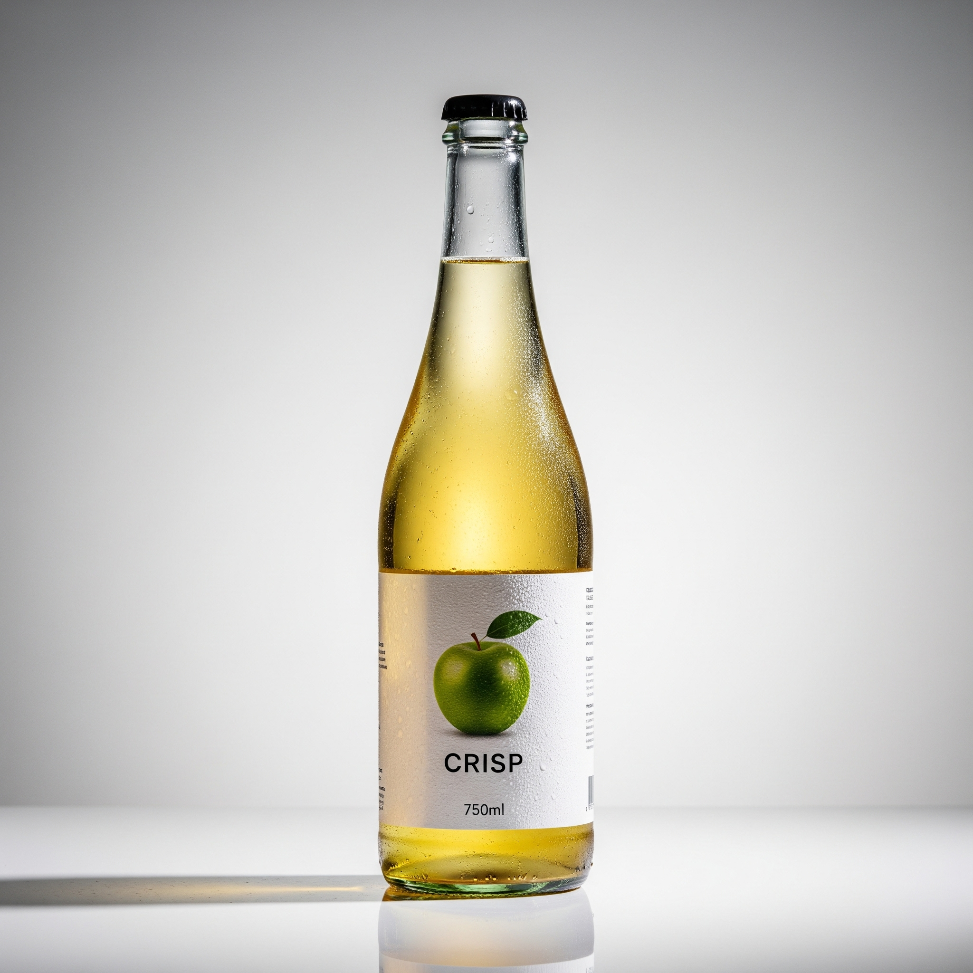

Pair 7: Trustworthiness vs Non-Trustworthy

A — Trustworthy

Prompt:

A middle-aged scientist in a laboratory filled with scientific instruments, showing a purity analysis graph of the beverage. Blue cool-toned lighting, professional, credible atmosphere.



B — Non-Trustworthy

Prompt:

A street vendor casually recommending a beverage at a small market stall. The scene looks unprofessional and informal.

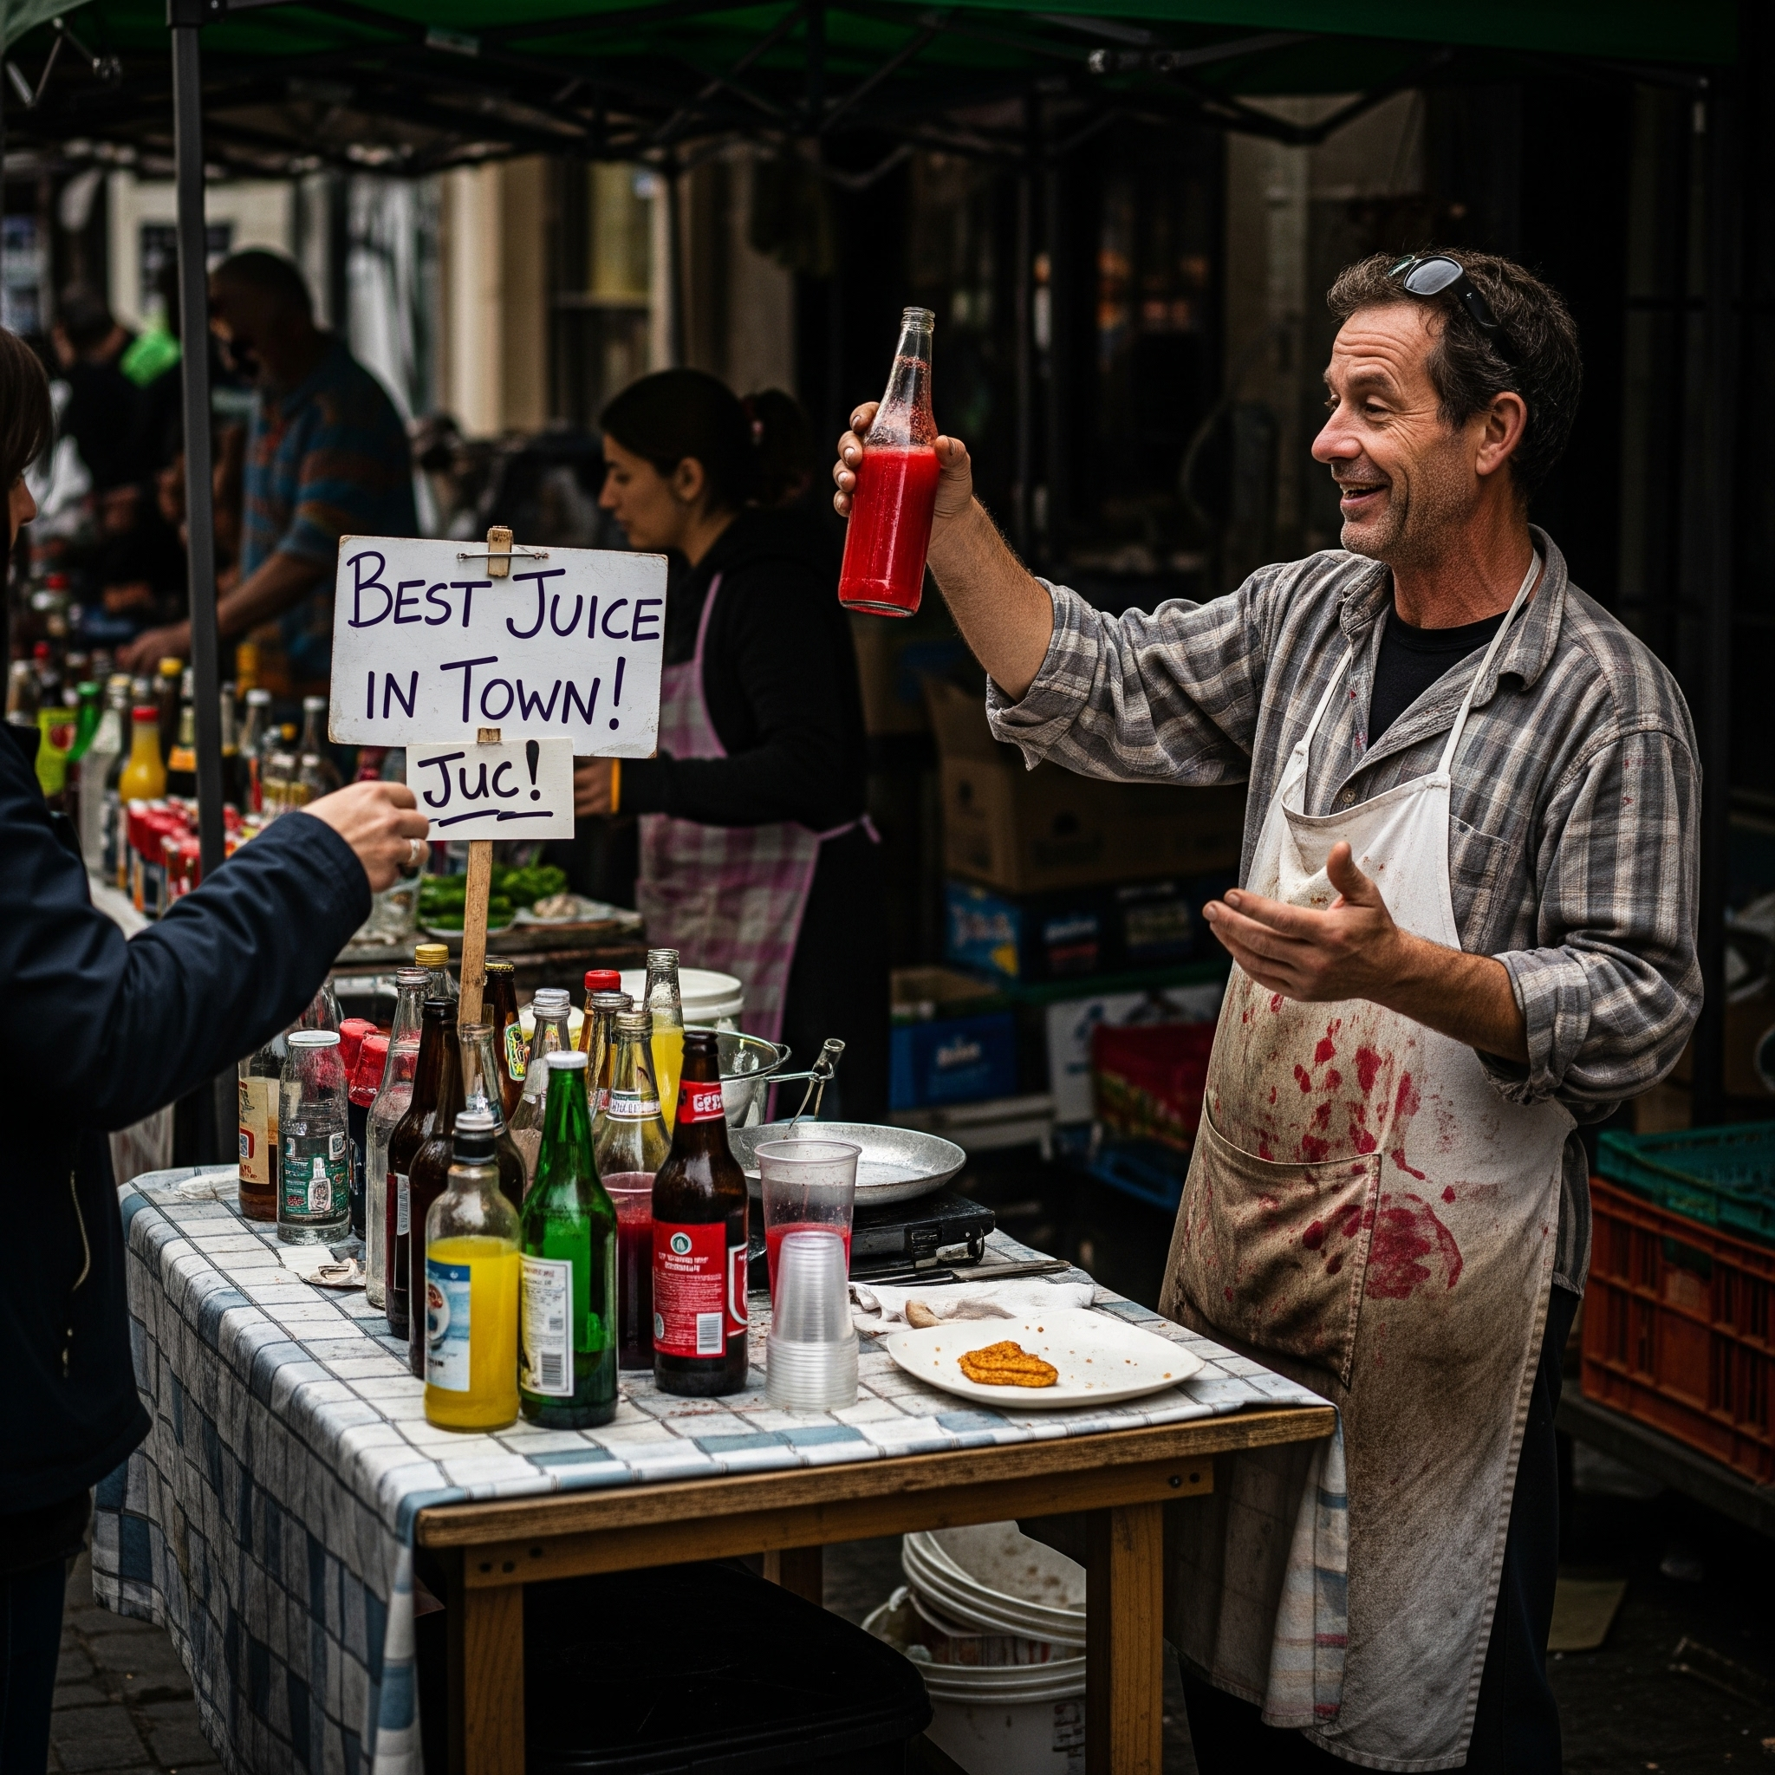

Pair 8: Familiarity vs Non-Familiar

A — Familiarity

Prompt:

A cozy home kitchen where a mother is pouring a beverage for her family. Warm lighting, familiar, comforting daily-life environment.

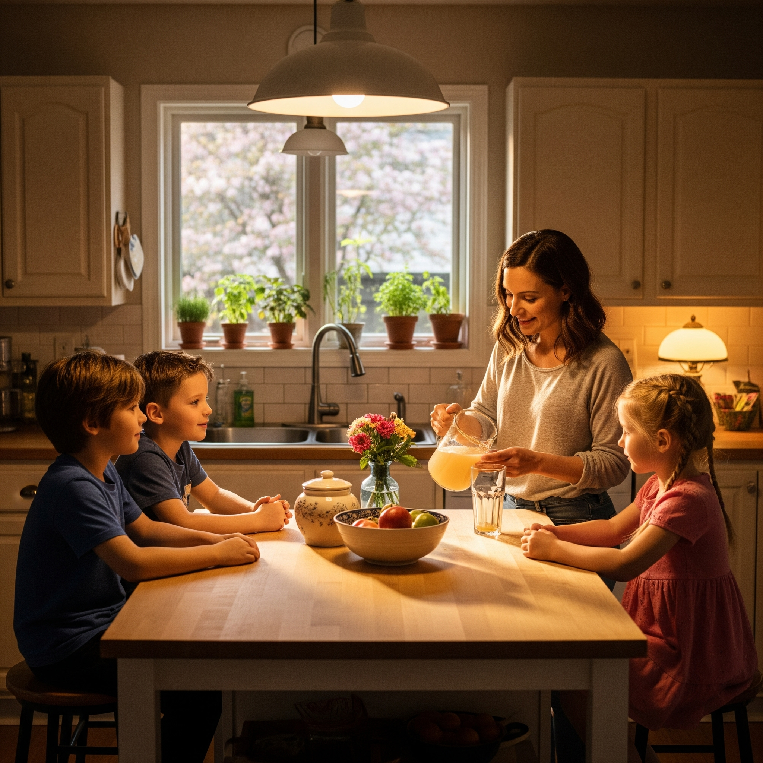

B — Non-Familiar

Prompt:

A futuristic sci-fi laboratory where the beverage bottle is floating in mid-air. Strange lighting, unfamiliar and non-domestic environment.

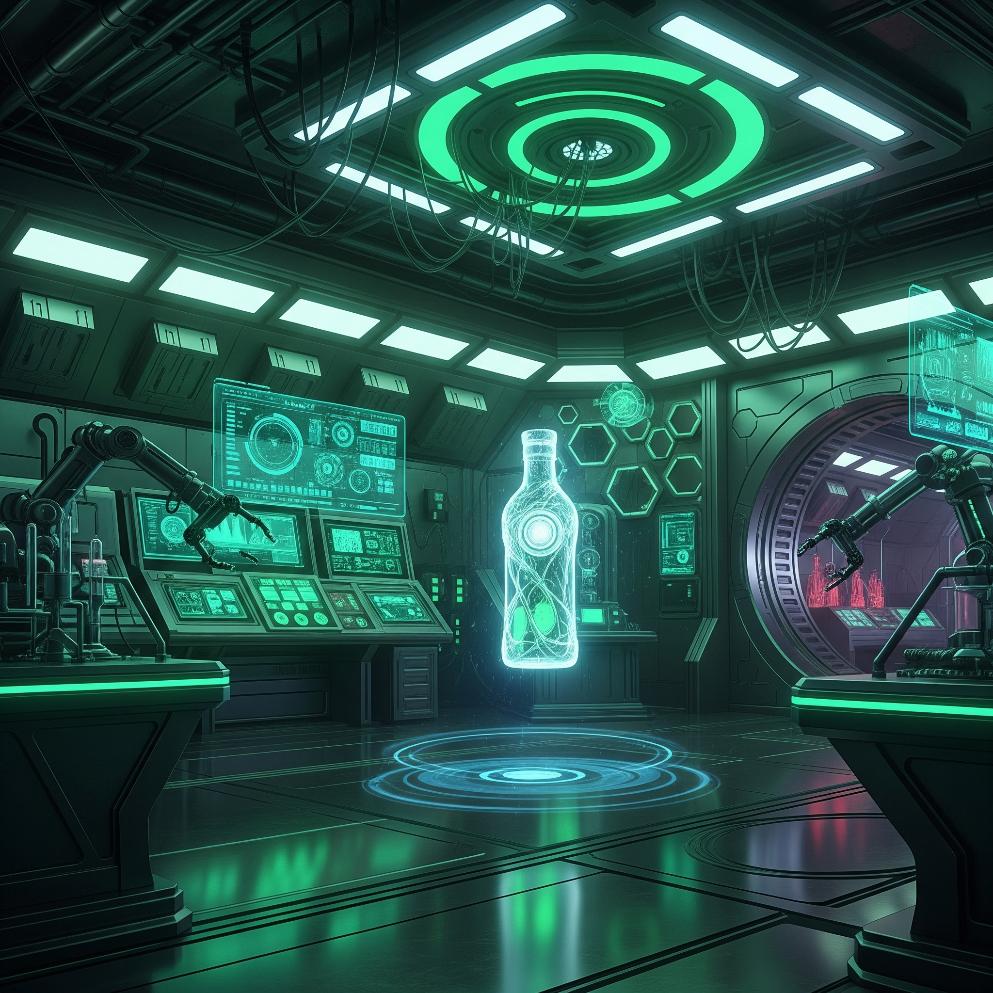

Pair 9: Novelty vs Non-Novelty

A — Novelty

Prompt:

A beverage bottle floating in zero gravity, with glowing effects, subtle distortion, or futuristic visual elements. High novelty, imaginative scene.

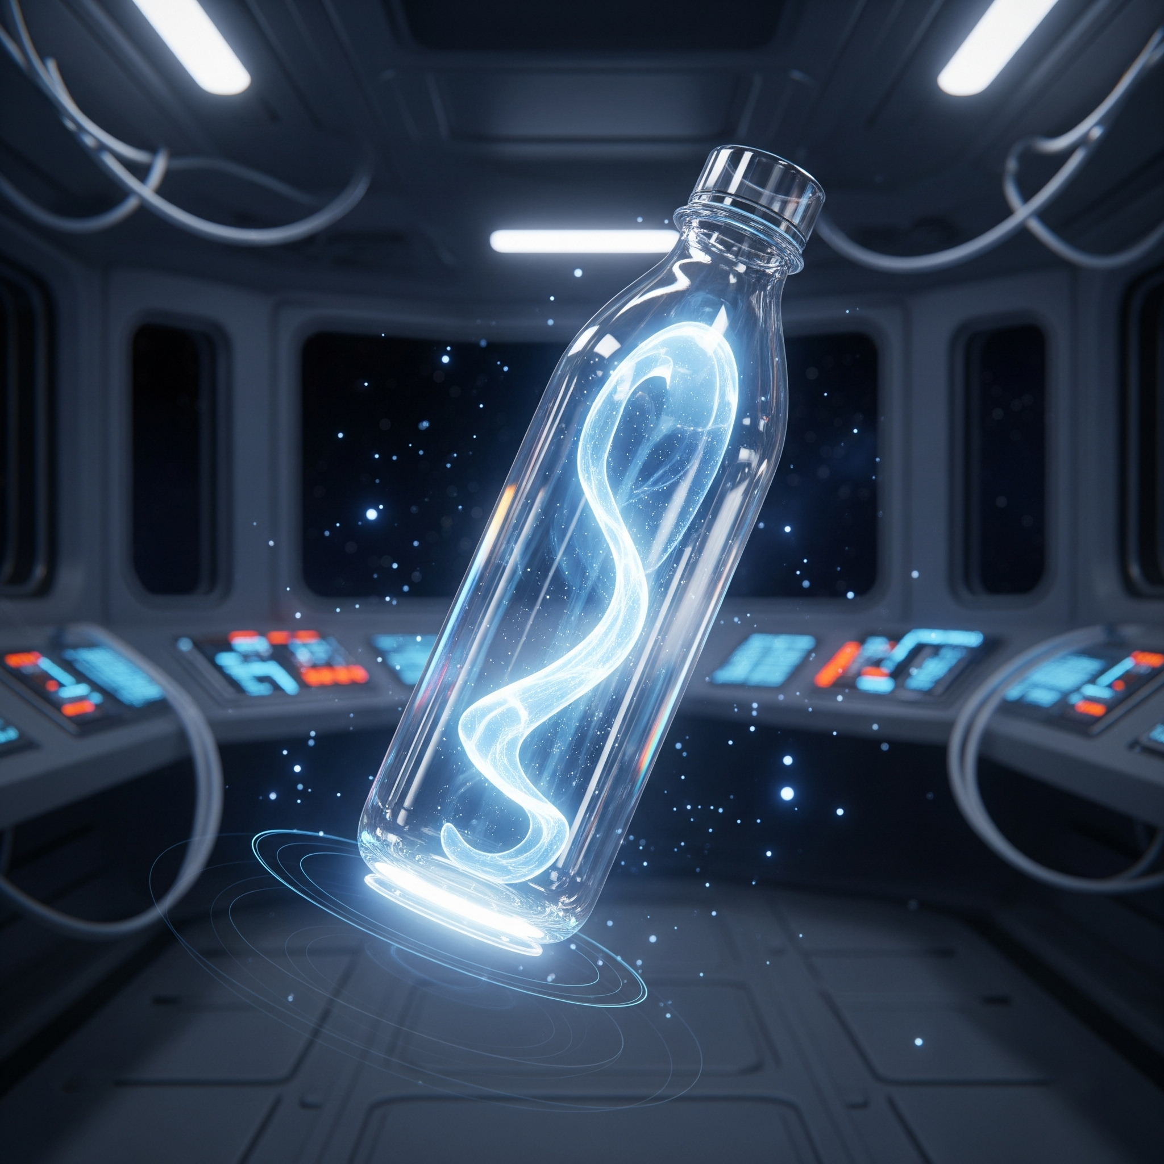

B — Non-Novelty

Prompt:

A normal beverage bottle placed on a table with no special effects, standard background, ordinary lighting.

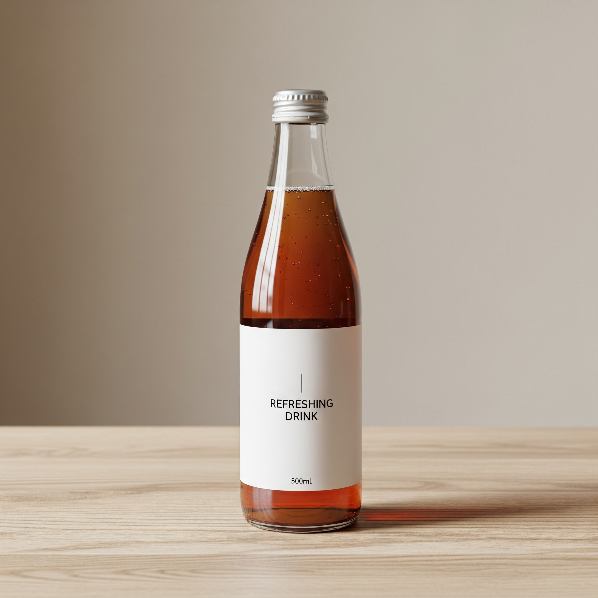

# Pairwise Comparison Prompt for LLM

You are a persuasion strategy analyst.

Task:

Given two images (Image A and Image B), choose which image better expresses the persuasion strategy: {PROPERTY_X}

Output format (very important):

- "Chosen Image: A/B"

- One-sentence explanation

Pair 1: Chosen Image: A

Explanation: The person in Image A is dressed as a doctor in a professional medical setting, which conveys strong authority cues compared to the casual young man in Image B.

# Persona Prompt

Assume you are a person with the following demographic traits:

Age: {AGE}

Gender: {GENDER}

Occupation: {JOB}

Personality: {BIG5_TRAITS}

Cultural background: {REGION}

Given the two images, which one would be more persuasive for someone like you?

Output:

- "As this persona, I choose: A/B"

- Explanation (2 sentences)